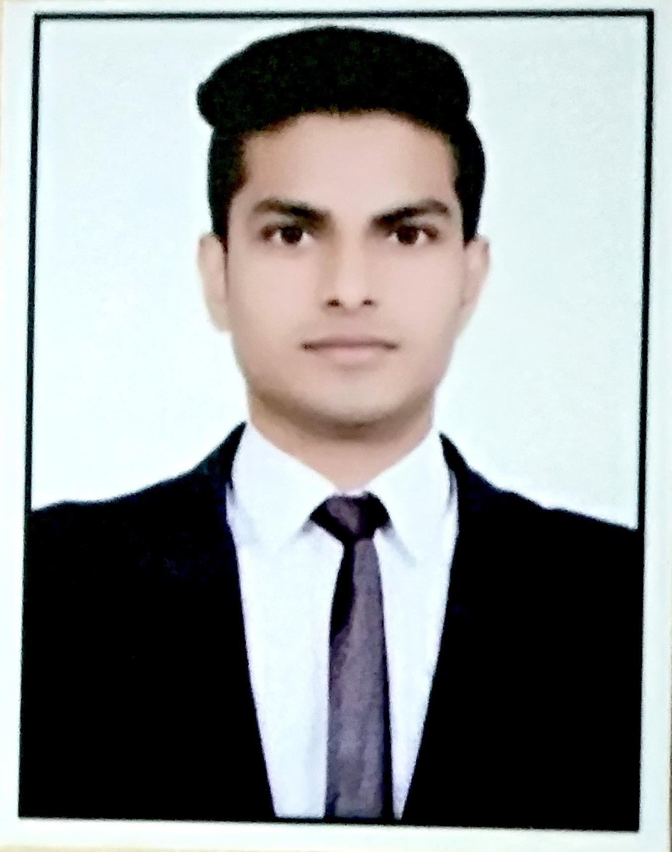 | AMIT  - BHARTI  HOTELIER
CONTACT  Delhi, India 110094  +919868709646  amit.bharti.18007@gmail.com  Passport no. R2831213  SUMMARY  Hardworking employee with customer service, multitasking and time management abilities. Devoted to giving every customer a positive and memorable experience.  SKILLS  .Housekeeping  .F&B Service  .Room Preparation  .Front Desk Communications  .Guest Services  .BOH  .Teamwork and Collaborations  .Food Safety  .Computer Skills  PERSONAL DETAILS  Nationality: Indian  Marital Status: Single  Date of Birth: 27 SEP 1996 | EDUCATION AND TRAINING  Janauary 2021  Bachelor of Arts  Delhi University, Delhi  July 2017  One Year Hotel Management Diploma  BTC PUSA, Delhi  July 2016  One Year Computer Software Diploma | Word Processing, PMS software  BTC PUSA, Delhi  Experience  August 2022 - January 2023  Room Attendant The Living Adventure Accor | Doha, Qatar  Bed making  Cleaned and returned vacant rooms to occupant-ready status.  Locked guest rooms after performing housekeeping services and maintained complete security.  Welcomed guests, provided answer to questions and anticipated guests’ service needs.  Moved beds, sofas and small furniture to wipe down baseboards and remove dust and dirt from hard-to-reach areas.  Laundered sheets and removed stains to restore linens to pristine condition.  Communicated with maintenance team on damages to repair.  January 2018 - February 2019  Waiter Five Star Hotels | Delhi, India  Daily Events  ACHIEVEMENTS AND AWARDS  Appreciation for valuable contributions on the occasion of The Qatar Global Sports Events 2022  LANGUAGES SKILLS  English, Hindi

