# **NITIN**

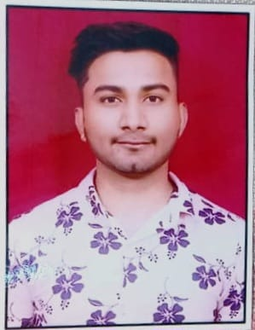

PhoneNo:9289730093

Email-Id: nitin9686525@gmail.com

Address:B-4/298, Sultan Puri New

Delhi-110086

## **CAREEROBJECTIVE**

To Produce Outstanding Results for My Organization By Applying My Skills And Aptitude Which I Have Acquired Throughout My Career, And Thereby Ensure Growth Of My Organization And Further Enhance My Professional Growth.

# **EDUCATIONALQUALIFICATIONS**

|  |  |  |  |  |
| --- | --- | --- | --- | --- |
| Class | Board/University | School/College | Year of Passing | Percentage |
| Graduation | Delhi University | School of open learning | 2018 | 47.00 |
| XII | C.B.S. E | Sarvodaya Bal Vidyalaya | 2015 | 80.00 |
| X | C.B.S. E | Sarvodaya Bal Vidyalaya | 2013 | 55.00 |

## **TECHNICALSKILLS**

* OperatingSystem:Windows8,Windows7,WindowXPAndVista.MSOffice.

# **EXPERIENCES**

* 3 Year Experience at DTDC Express Pvt. Ltd as a Operation executive.
* 1 Year Experience at Nikon India Pvt. Ltd. As a ISD executive
* 2 Year Experience at Shetala Agenesis Pvt. Ltd as a Sales Executive.
* Currently Working in Fujifilm India Pvt. Ltd As a Sales Consultant.

## **HOBBIES**

* Listening To Music.
* Video Editing.

# **STRENGTH**

* Knowledge about the camera field.

# **PERSONALDETAILS**

Date Of Birth

Father Name

Gender

Marital Status

Nationality

Languages Known

12-05-1998

Mr. Anil Kumar

Male

Married

Indian

Hindi English,

## **DECLERATION**

I do here by declare that the above-mentioned information is true to the best of my knowledge.

Place:

Delhi:

**(NITIN)**