SANJAY KUMAR PRADHAN
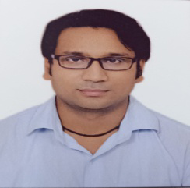  CONTACT  +91-9560641739  Sanju.sanjaypradhan@gmail.com  L-37,Fourth Floor Laxmi Nagar Behind Beni Sweets  Delhi 110092  https//www.linkedin.com/In/sanjay-pradhan-b8ab87134  KEY SKILLS  Communication skills  Team Worker  Punctuality  Time Management skills |  |  | PROFILE  Dynamic Result oriented Sales and Marketing Promotion Planner. Record of Achievements while Providing Visionary sales leadership in highly  Competitive Markets. Good track record of Securing client & increasing Product  Distribution to grow market share.  CERTIFICATIONS  Basic Computer knowledge  PROFESSIONAL EXPERIENCE  5 Years of Experience at Prabhat Prakshan Pvt. Ltd. as a ASM.  6 months of Experience at Printmart India inc. As a ASM.  2 years of Experience at Q CONNECT As a Duty manager  3 Years of Experience at Elora International Limited as a Branch manager  Tour Area  DELHI,NOIDA,HARIYANA AND CHANDIGARH  Education  Graduate B.A (Hons) Political Science from Delhi University  Senior Secondary (XIIth) from C.B.S.E Board Delhi.  Secondary (Xth) from C.B.S.E Board Delhi  Personal Details –  D.O.B. 26-01-1990  Sex Male  Nationality Indian  Marital Status Married  Languages Hindi , English  Father Name Rajkumar Pradhan  Mother Name Anita pradhan  Declaration –  I hereby declared that all the above information furnished by me is correct and true to best of my knowledge and belief.  Place - DELHI Sanjay Kumar Pradhan
·

