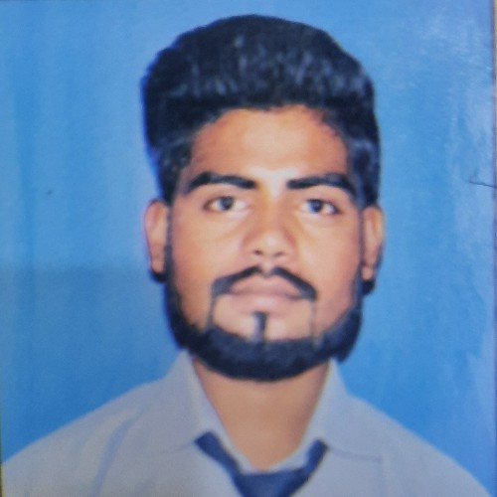

Current Address-: Hoshiyarpur sector 51 near sector 34 metro station Noida Uttar Pradesh 201301 Permanent Address-: 23/213B Wazirpura Agra Uttar Pradesh 282003 6395033578 | [Nicdiwakar29@gmail.com](mailto:Nicdiwakar29@gmail.com)

https:/[/www.linkedin.com/in/gaurav-diwakar](http://www.linkedin.com/in/gaurav-diwakar) 74a8351bb

For seeking challenging opportunity in a reputed organization so as to utilize our professional as well as generic skills by doing effective work and contributing towards growth prospectus of your esteemed organization

01/05/2022 - 13/03/2023

Pantheon Digitals PVT LTD

Understand the requirements

* Sourcing , Screening , Cold calling
* Arrenging Interviews
* Answer employees queries about HR-related issues
* Coordinate With Client

, Screening , Cold calling

* Arrenging Interviews
* Revise company policies
* Answer employees queries about HR-related issues
* Organize and maintain personnel records
* Coordinating with clients
* Taking inhouse interviews

15/03/2023 - 30/12/2023

Kickchef Hospitality Solutions

☆

Understand the requirements

* Sourcing , Screening , Cold calling
* Arrenging Interviews
* Revise company policies
* Answer employees queries about HR-related issues
* Coordinate With Client
* Sourcing Hospitality Department for Reference and Social media
* Taking Inhouse Interview

•Maintain candidates Reconds

* Maintain Daily Attendance
* Discuss Salary part & Negotiation
* Handling New project and Recruitment process
* Taking Interview for a Senior Position as Manager or Head Chef
* Induction and Onboarding Process

20/01/2024 - 30/04/2024

NetAmbit

☆ --

* Understand the requirements
* Sourcing , Screening , Cold calling

|  |  |  |  |
| --- | --- | --- | --- |
| * Arrenging Interviews * Revise company policies * Answer employees queries about HR-related issues * Organize and maintain personnel records * Coordinating with clients * Taking inhouse interviews * On bonding & Induction Process * Team Handling | | | |
|  | | | |
|  |  |  |  |
| 10th | R.B.S. inter college | 66% | 2015 |
| 12th Science(PCM) | R.B.S Inter college | 50% | 2017 |
| Bachelor of Business administration | Dr. BhimRao Ambedkar University agra | 62.6% | 2020 |
| Master of Business Administration | Dr. APJ Abdul kalam technical university | 61.5% | 2022 |

Excellent learner

Good Communication Cold calling

Team Handling Coordinate With Client/ Manager Client Relationship

Sourcing specialist Team handling



Marketing & HR



Hindi English

|  |  |
| --- | --- |
|  | |
| Gender | Male |



|  |
| --- |
| Hard work , Good communication Problem solver |
|  |
|  |



Exploring New places Watching Movies

Listen Music



I have by declare that all details finish above are true and best of my knowledge and below



Indian

Male



12/06/1998



Responsible Patience



GAURAV DIWAKAR