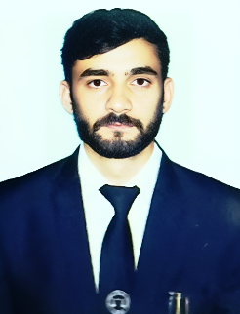

RAVINDER KUMAR

Address: VPO:- Mangleshwar,

Tehsil-Bawal, District Rewari(HR)

Mobile No: -+918930927588

E-mail:-Raviender2098@gmail.com

**Career objectives:**

* To attain the confidence of the company using my expertise in the field of Computer Operating with my work thereby approaching a positive growth for my career along with the cherished reputation of the organization.

**Work Experience:**

* 2 year work experience as Lawyer in District & Session Court, Rewari.

**Education Qualification:**

|  |  |
| --- | --- |
| 2015 | 10th Passed from Haryana Bhiwani Board with 82% marks. |
| 2017 | 12th Passed from Haryana Bhiwani Board with 67% marks. |
| 2022 | BA LLB. Passed from IGU, Meerpur, Rewari with 61% marks. |

**Professional Qualification:**

* 3 Month Certificate in Domestic Data Entry Operator from PMKVY, Rewari

**Strength:**

* Good Judgment/ Problem Solving Skills when making decision.
* Good communication Skills.
* Ability to Monitor a Team with Hard Work.

**Personal Profile:**

* Father's Name : Sh. Lalit Kumar
* Date of Birth : 01-04-2000
* Marital Status : Unmarried
* Sex : Male
* Nationality : Indian
* Language Known : Hindi & English

**Declaration:**

* I hereby declare that the above all information is true to the best of my knowledge and belief.

Place :

Date : (**RAVINDER KUMAR**)