Nishchay Gupta

Graphic Designer

[nishchayg9675@gmail.com](mailto:nishchayg9675@gmail.com) 9149373168  Gali no.3 Old Suraksha Vihar Rohta Agra-282009  09/08/2003 Indian Unmarried  Male [https://www.linkedin.com/in/nishchay-gupta-4a37a4179/](http://www.linkedin.com/in/nishchay-gupta-4a37a4179/)

# Proﬁle

Motivated Graphic Designer with a strong passion for creating visually stunning designs and a keen eye for detail. Committed to contributing to team success through a combination of creativity, **technical expertise, and eﬀective** communication. Proﬁcient in Adobe Photoshop, Adobe Illustrator, and CorelDRAW, and continuously expanding

skill set to stay up-to-date with the latest design trends. With a solid foundation in design principles and a dedication to **delivering high-quality work, I am eager to leverage my skills and contribute to the growth of your compan**.**y** Seeking a full-time position that provides opportunities for professional growth, utilizing my interpersonal skills, excellent time management, and problem-solving abilities.

# Education

**Bachelor** *of Science, Dr. Bhimrao Ambedkar University*

## Diploma In Graphic Web Design And Development,

*Arena Animation*

**HIgher and Secondary Education, Baluni Public School**

# Professional Experience {More than 3 years}

04/2019 – 07/2022 | Agra

08/2019 – 09/2021 | Agra, India

04/2017 – 04/2019 | Agra

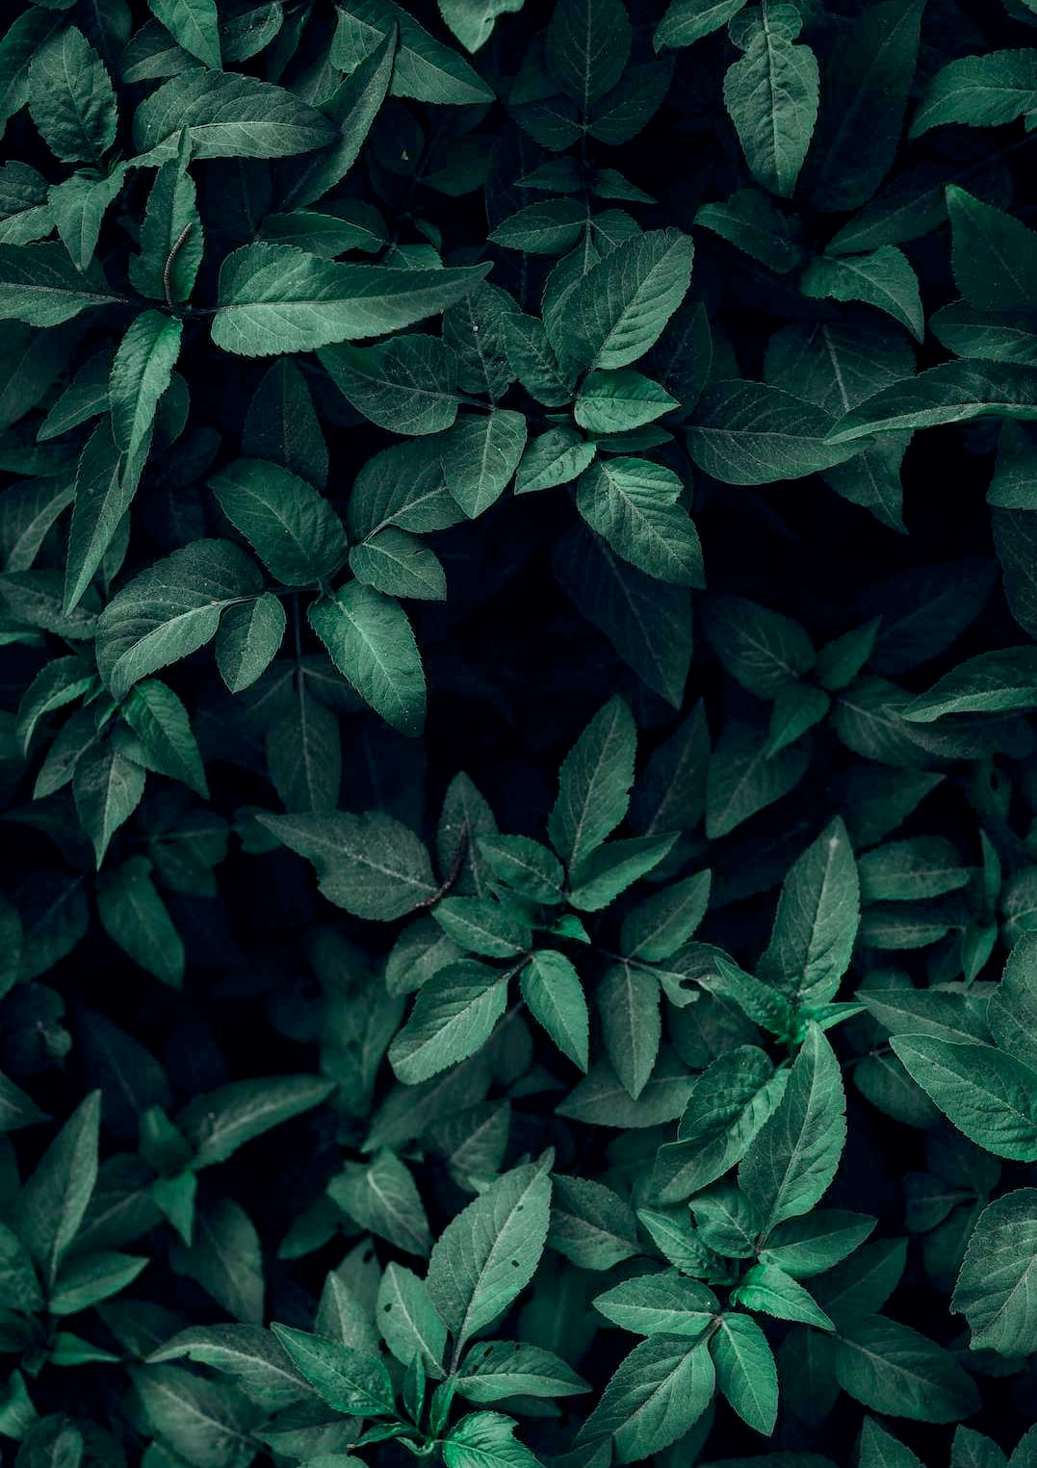

**Upkar Prakashan,** *Graphic Designer* 04/2022 – present

## Designed Creative Ads, templates and unique branded looks.

Carried out day-to-day duties accurately and eﬃciently.

Identiﬁed issues, analyzed information and provided solutions to problems.

**Ambar Advertisers, Graphic Designer** 12/2021 – 03/2022 | Agra, India Developed visually appealing templates, and unique branded looks for clients.

Utilized design principles to select appropriate **typography, composition, layout, and color schem**i**e**n**s**design projects.

## Conducted comprehensive product design tests using the latest software tools.

Generated high-qualitydigital image ﬁles suitable for both digital and traditional printing methods.

*HS Ayurveda Ltd, Graphic Web Designer* 07/2020 – 11/2021 | Agra Designed website layouts, templates and unique branded looks.

Employed design fundamentals when selecting typography, composition, layout and color in design work. Completed in-depth product design tests using updated software tools.

Created digital image ﬁles for use in digital and traditional printing methods.

Developed creative design for print materials, banners and signs.

# Skills

Graphic design Adobe Photoshop

# Languages

Corel Draw

Adobe Illustrator

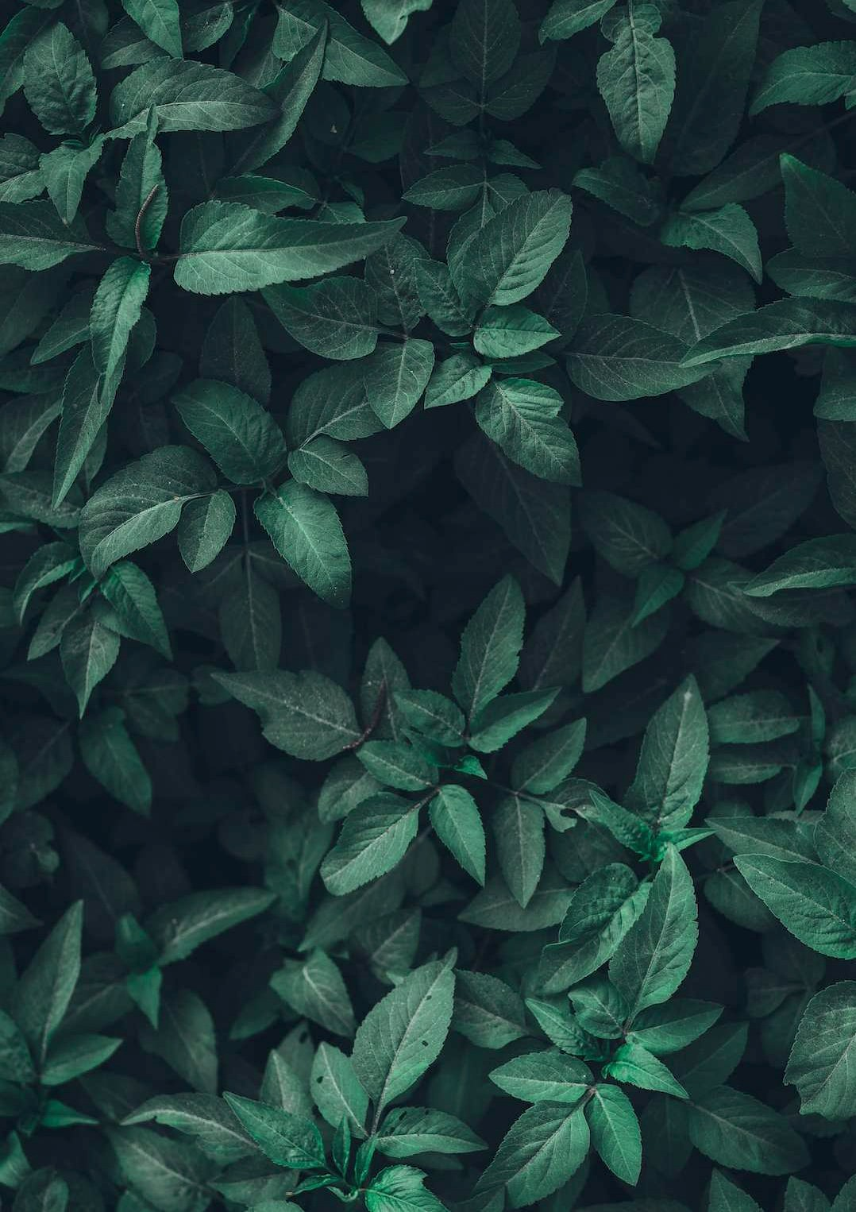

**English**

**Hindi**

# Certiﬁcates

**https://drive.google.com/ﬁle/d/1wkoHBOcmxOs3-vBJ0wtGubYNNm7Ld8xC/view?usp=sharing (Arena Certiﬁed Professional In Graphics Web Design And Development)**

**Projects**

## https://drive.google.com/drive/folders/1AxpXqhaKj5Zz7lPH2oRIDUDTwhXIRD_F?usp=sharing

*Graphic Designing Portfolio* **https:/**[**/w**](http://www.91digitals.com/)**w**[**w.91digitals.com/**](http://www.91digitals.com/) **https://fourallies.com/ https://matrixglobalinfotech.in/**

# Declaration

I also aﬃrm that the samples of my work, portfolio, and resume submitted are original and represent my own work. I take full responsibility for the authenticity and quality of the materials provided.

## Nishchay Gupta

Agra