RESUME

KULDEEP SARASWAT 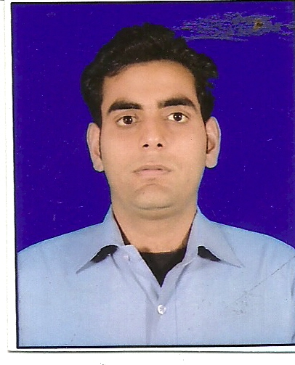
Address: A-85 Harit Vihar Burari Delhi
Contact: (M) +9599505421
DOB : 29 August 1989
Email id: kuldeep290889@gmail.com

Career Objective:

I would like a career that gives me a rich exposure and differentiate from others and use my skills in the best possible way for achieving the company goals.

Academic Qualification:
DEGREE | INSTITUTE | UNIVERSITY/BOARD | CGPA/% | YEAR
MBA | School of Business | Galgotias university | 8.12 | 2011-2013
BBA | Mewar Institute | Chaudhary Charan Singh University | 66.39 | 2008-2011
12th | Shakti Nagar | CBSE board | 55.4 | 2008
10th | S.N.B.S.S. S | CBSE board | 62 | 2006

Area of specialization
- MARKETING AND FINANCE

Work Experience

COMPANY - INFRA EQUITY PVT. LTD.
PROCESS - INSIDE SALES
DURATION - MAY 2023 TO CONTINUE
DESIGNATION - SR. EXECTUIVE -BUSINESS DEVELOPMENT
KEY RESPONSIBILITIES –Infra Equity is a Start-up company under brand name Mistry. Store. Mistry. Store is B2B platform to provide building materials to Architects, Interior Designers, Contractors and Builders in NCR Location. This is gurgaon based company. I am working as a Sr. Executive Business Development in this company. I am responsible for b2b sales in company. Basically, I am working with new as well as existing both clients and generate revenue for the company. During my tenure, I performed well and achieved revenue targets. I added some big b2b clients who is doing turnkey projects like Yellowcsps Infracon, Swakriti Construction, Jagannath Enterprises and Azure press pvt ltd and many more. This is all about my current experience.

Work Experience

COMPANY - TRADE INDIA
PROCESS - SALES
DURATION - MAY 2022 TO MAY 2023
DESIGNATION - RELATIONSHIP MANAGER (ASSISTED SALES)
KEY RESPONSIBILITIES –Trade India is one of India’s largest and oldest B2B e-commerce platforms that connects buyers and suppliers to create a customer-driven value chain for all businesses, including SMEs, large enterprises and individuals. This is Noida-based company. I was working as a Relationship Manager in this company. I was responsible for online sales in company. Basically, I was dealing with Existing Clients who already paid trade india for new services. In EC business, we were taking care of 3 things: 1. Servicing 2. Upgrade and 3. Renewal. This was targeting based job and i was handling 80 to 100 clients based. This was all about my trade india experience.

Work Experience

COMPANY - VENTURE BRIKS
PROCESS - SALES
DURATION - JULY 2021 TO APRIL 2022
DESIGNATION - TELE - SALES EXECUTIVE
KEY RESPONSIBILITIES –Venture Briks was Real Estate Channel Partner company that was working in multiple locations. This company was working in Gurgaon, Noida, Mumbai, Pune, Thane, Bangalore and started in international location Dubai. This was Gurgaon-based company. This company was doing business with A-grade builders. I was working as a tele-sales executive in this company. I was responsible for lead generation in this company. I was responsible for generate 2 meetings on a daily basis and assigned these leads to sales team on the basis of territory. This was targeting based job and on basis of my performance i already confirmed by the company in the 3 months. This was all about my Venture Bricks company experience.

Work Experience

COMPANY - DJT CORPORATION AND INVESTMENT PVT. LTD
PROCESS - SALES
DURATION - JANUARY 2020 TO AUGUST 2020
DESIGNATION - SALES CONSULTANT
KEY RESPONSIBILITIES – DJT is Investment company that is working in three sectors- Investment, Insurance and
Retail. I was working in insurance sector as a sales consultant. I was responsible for online sales in company. Basically, company was service provider. DJT had all the brands to display on online platform for example: Max, Hdfc, Canara and Pnb many more etc. I had called the customers and present the insurance product as per customer requirement. I was responsible for inside sales and provide end solutions to customers.

Work Experience

COMPANY - TELEPERFORMANCE
PROCESS - ZOMATO (SALES)
DURATION - OCTOBER 2018 TO OCTOBER 2019
DESIGNATION- CUSTOMER SERVICE ASSOCIATE
KEY RESPNSIBILITIES- This is Multi -National Company. I was working as Customer Service
Associate in this company. I was responsible for online sales in this company. Zomato had launched new product ‘Zomato Gold' membership. This was Zomato dine-out program which was introduced in year 2018. I was promoting Zomato gold membership. I was calling the customers and present the new offers which was running by Zomato. I was responsible for achieving revenue target that was given by company. This is all about Tele performance Experience.

Work Experience

COMPANY - RELIGARE HEALTH INSURANCE
DURATION - AUGUST 2017 TO August 2018
DESIGNATION- RELATIONSHIP MANAGER
KEY RESPONSIBILITIES- This is Health Insurance Company. I started my professional journey from this company, I was working as online Relationship Manager in this company. I was calling the customers and present the insurance product to customers. I was promoting the product as per customer requirement and secure the customers through health Insurance. I was responsible for achieving revenue target and give end solution to customers.

Summer Internship:

COMPANY - HDFC LIFE
DURATION - Six weeks
DESIGNATION-Financial consultant
PERIOD - July 14 to August 30 2012
PROJECT – Comparative Analysis of Insurance Companies, And Consumer Behavior

Key learning’s
- To Analysis Need of The People
- Provide Solution about their Future Financial Need.
- Working with the team

Computer Skills:
- General: basics of Computer
- Email and Internet

Skill Set:
- Team player
- Goal oriented
- Ability to learn new concepts and technology with in short span of time

Strengths and key skills:

- Ability to work with self-confidence, full potential and positive attitude.
- Hard working and team player with high career goal.

Personal Details:

Correspondence : Ram Niwas Sharma
Date of Birth : August 29 1989
Marital Status : Married
Gender : Male
Nationality : Indian
Language : English, Hindi

Declaration:

I hereby solemnly affirm that all the details provided above are true to the best of my knowledge.

Date: KULDEEP SARASWAT

Place: DELHI

